Student Result Processing System and Grade Generation File Based Record Processing

A CAPSTONE PROJECT REPORT
Submitted in the partial fulfillment for the award of the degree of

CSA0203- C PROGRAMMING
To the award of the degree of

BACHELOR OF ENGINEERING IN
COMPUTER SCIENCE AND ENGINEERING

Submitted by

R. JAIDEEP (192525441)

B. BHANU PRAKASH (192412518)

P. JEEVAN KUMAR (192572090)
Under the supervision of

Dr. S. K. Saravanan

SIMATS ENGINEERING
Saveetha Institute of Medical and Technical Sciences
Chennai-602105 September 2026
















DECLARATION

We, R. Jaideep, B. Bhanu Prakash, and P. Jeevan Kumar of the Computer Science and Engineering Department and Electronics and communication Department, Saveetha Institute of Medical and Technical Sciences, Saveetha University, Chennai, hereby declare that the Capstone Project Work entitled ‘Student Result Processing System and Grade Generation File Based Record Processing’is the result of our own Bonafide efforts. To the best of our knowledge, the work presented herein is original, accurate, and has been carried out in accordance with principles of engineering ethics.

Place:
Date:

Signature of the Students with Names

R. JAIDEEP (192525441)

B. BHANU PRAKASH (192412518)

P. JEEVAN KUMAR (192572090)







BONAFIDE CERTIFICATE

This is to certify that the Capstone Project entitled “Student Result Processing System and Grade Generation File Based Record Processing” has been carried out by MOHANALAKSHMI S and VIDULA R under the supervision of Dr. S.K. Saravanan and is submitted in partial fulfilment of the requirements for the current semester of the B.E Computer Science and Engineering program at Saveetha Institute of Medical and Technical Sciences, Chennai.

SIGNATURE SIGNATURE

Dr. P. Sriramya Dr. S. K. Saravanan
Program Director Professor
Department of AIDS Department of CSE
Saveetha School of Engineering Saveetha School of Engineering
SIMATS SIMATS

Submitted for the Project work Viva-Voce held on

Internal Examiner External Examiner

ACKNOWLEDGEMENT
We would like to express our heartfelt gratitude to all those who supported and guided us throughout the successful completion of our Capstone Project. We are deeply thankful to our respected Founder and Chancellor, Dr. N. M. Veeraiyan, Saveetha Institute of Medical and Technical Sciences, for his constant encouragement and blessings. We also express our sincere thanks to our Pro-Chancellor, Dr. Deepak Nallaswamy Veeraiyan, and our Vice Chancellor, Dr. S. Suresh Kumar, for their visionary leadership and moral support during the course of this project.

We are truly grateful to our Director, Dr. Ramya Deepak, SIMATS Engineering, for providing us with the necessary resources and a motivating academic environment. Our special thanks to our Principal, Dr. B. Ramesh for granting us access to the institute’s facilities and encouraging us throughout the process. We sincerely thank our Head of the Department, Dr. S. Anushya for her continuous support, valuable guidance, and constant motivation.

We are especially indebted to our guide Dr. S. K. Saravanan for her creative suggestions, consistent feedback, and unwavering support during each stage of the project. We also express our gratitude to the Project Coordinators, Review Panel Members (Internal and External), and the entire faculty team for their constructive feedback and valuable inputs that helped improve the quality of our work. Finally, we thank all faculty members, lab technicians, our parents, and friends for their continuous encouragement and support.

Signature With Student Name

R. Jaideep (192525441)

B. Bhanu Prakash (192412518)

P. Jeevan Kumar (192572090)

TABLE OF CONTENTS
S.NO | CONTENTS | PAGE NO.
1. | Abstract | 7
2. | Chapter 1: Introduction  - Introduction  - Need for the project  - Purpose of the project | 8-10
3. | Chapter 2: Literature survey  - Manual result processing system  - Spreadsheet based processing system  - File based recoding system  - Student information management system | 11-13
4. | Chapter 3: System analysis  - Problem identification  - Existing system  - Proposed system  - Objectives of the proposed system  - Scope of the system | 14-16
5. | Chapter 4: system design  - System architecture  - Module design  - Input and output design | 17-21
6. | Chapter 5: implementation  - Implementation of modules  - Program execution and sample outputs | 22-25
7 | Conclusion | 26
8 | Reference | 27

ABSTRACT

The Student Result Processing System and Grade Generation Using File-Based Record Processing is a software application developed to automate the management of student examination records and simplify the process of result generation in educational institutions. In many schools and colleges, student results are still prepared manually or using basic spreadsheet applications, which can be time-consuming, prone to calculation errors, and difficult to maintain as the number of students increases. The proposed system addresses these challenges by providing an efficient, reliable, and user-friendly solution based on file handling techniques.

The system stores student information, including roll number, name, department, semester, and subject-wise marks, in files. It automatically calculates the total marks, percentage, grade, and pass/fail status according to predefined grading criteria. The application also provides facilities for adding new student records, searching existing records, updating marks, deleting records, and generating detailed result reports. Since all records are maintained in files, the data remains permanently available for future reference without requiring a database management system.

The project emphasizes the use of file-based record processing, making it suitable for small and medium-sized educational institutions where a lightweight and cost-effective record management solution is preferred. By automating calculations and report generation, the system significantly reduces manual effort, improves processing speed, eliminates computational errors, and ensures consistency in grading. The modular design of the application also makes it easy to maintain and extend with additional features.

The system is developed using programming concepts such as file handling, conditional statements, loops, functions, and structured data management. It demonstrates the practical implementation of software engineering principles in solving real-world academic administration problems. The application is easy to operate, requires minimal technical knowledge, and can be implemented using programming languages such as C, C++, Java, or Python.

The proposed system offers several advantages, including improved accuracy, faster result processing, permanent storage of academic records, reduced paperwork, and simplified record maintenance. It also supports efficient retrieval and modification of student information whenever required. The generated reports provide clear and accurate information regarding student performance, making them useful for students, teachers, and academic administrators.

In conclusion, the Student Result Processing System and Grade Generation Using File-Based Record Processing provides a practical, economical, and efficient solution for managing student examination records. It enhances the overall efficiency of the result preparation process by automating calculations, ensuring reliable data storage, and reducing administrative workload. With future enhancements such as database integration, online result publishing, cloud storage, and mobile application support, the system can be expanded into a comprehensive academic information management system capable of serving larger educational institutions.

CHAPTER – 1 INTRODUCTION
1.1 Introduction
Educational institutions are responsible for maintaining the academic records of thousands of students every academic year. One of the most important administrative activities performed by schools, colleges, and universities is the processing of examination results. This process involves collecting subject-wise marks, calculating total marks, determining percentages, assigning grades, and preparing final result reports. Traditionally, these tasks were performed manually using paper records or spreadsheets. Although this method may work for a small number of students, it becomes inefficient and error-prone as the number of students increases.

The Student Result Processing System and Grade Generation Using File-Based Record Processing has been developed to overcome these challenges by providing an automated solution for managing student examination records. The system stores student information in files, processes examination marks automatically, calculates academic performance, and generates grades according to predefined grading criteria. By eliminating manual calculations, the system improves accuracy, reduces processing time, and minimizes human errors.

File-based record processing is one of the fundamental methods of storing data in computer systems. Instead of maintaining records manually or using complex database software, this project stores all student information in files. The records can be easily created, retrieved, updated, deleted, and displayed whenever required. File handling provides permanent storage, allowing institutions to preserve academic records safely for future reference.

Automation has become an essential requirement in modern educational institutions. Computerized systems help administrators manage large volumes of student information quickly and efficiently. A result processing system not only reduces paperwork but also provides instant access to academic records, enabling teachers and administrators to prepare results in a shorter time. This improves the overall efficiency of the examination process while ensuring fairness and consistency in grading.

The proposed system consists of several functional modules, including student registration, marks entry, result calculation, grade generation, file management, report generation, and record maintenance. Each module performs a specific task, ensuring that the overall system remains organized, reliable, and easy to use. The system can be implemented using programming languages such as C, C++, Java, or Python, making use of file handling concepts for data storage.

One of the major advantages of this project is that it does not require a database management system, making it economical and suitable for small and medium-sized educational institutions. Since the application is based on file handling, it consumes fewer system resources and is easy to maintain. The software also supports operations such as searching for student records, updating marks, deleting records, and generating detailed result reports whenever necessary.
1.2 Need for the Project
Educational institutions face several challenges while processing examination results manually. Some of the major needs for developing this system are:
- To reduce the time required for preparing examination results.
- To eliminate calculation errors in total marks and percentages.
- To maintain permanent student records using files.
- To improve the accuracy of grade generation.
- To simplify searching and updating student information.
- To reduce paperwork and manual documentation.
- To provide quick access to student academic records.
- To improve the efficiency of examination management.
- To minimize administrative workload.
- To ensure consistency in grading and result preparation.

1.3 Purpose of the Project
The primary purpose of the project is to develop an automated software application that manages student academic records efficiently using file-based storage. The system simplifies the entire result processing workflow by performing calculations automatically and generating accurate grades and reports. It also demonstrates the use of file handling techniques in developing a real-world application.

CHAPTER -2
LITERATURE SURVEY
2.1Manual Result Processing System
Before the introduction of computers, examination results were prepared manually. Teachers collected subject marks, calculated totals and percentages, assigned grades, and prepared mark sheets by hand. Student records were maintained in registers and paper files.
Although this approach required minimal technology, it had several disadvantages. Manual calculations were time-consuming and often resulted in errors. Searching for old records was difficult, and maintaining large volumes of paper documents required significant storage space. Updating or correcting records was also complicated and increased administrative workload.
Advantages
- Easy to understand.
- No computer knowledge required.
- Low initial investment.
Disadvantages
- High possibility of calculation errors.
- Slow result preparation.
- Difficult record maintenance.
- Large amount of paperwork.
- Risk of losing or damaging records.
- Inefficient for large institutions.

2.2 Spreadsheet-Based Result Processing
Many educational institutions later adopted spreadsheet applications such as Microsoft Excel for preparing examination results. Spreadsheet software provides built-in formulas that automatically calculate totals, percentages, averages, and grades.
While spreadsheets reduce calculation errors and improve processing speed, they are not specifically designed for student record management. Managing large numbers of students becomes difficult, and accidental modification of formulas or data may affect the accuracy of results.
Advantages
- Automatic calculations.
- Easy report generation.
- Faster than manual processing.
- Supports sorting and filtering.
Limitations
- Limited security.
- Difficult to manage very large datasets.
- Risk of accidental data modification.
- No structured file management.
- Limited multi-user support.

2.3 File-Based Record Processing
File-based record processing stores information directly in computer files without requiring a database management system. Student information is stored in sequential or structured files and can be accessed using file handling operations.
The proposed project uses this technique because it is simple, economical, and suitable for educational institutions with a moderate number of students.
File Operations Used
- File creation.
- Reading records.
- Writing records.
- Updating records.
- Searching records.
- Deleting records.
- Closing files.
Advantages
- Permanent data storage.
- Easy implementation.
- Low development cost.
- Faster than manual systems.
- Suitable for small and medium institutions.
Limitations
- Slower than databases for very large datasets.
- Limited data security.
- No support for multiple users simultaneously.
- Manual backup management.

2.54Student Information Management Systems
Student Information Management Systems (SIMS) are software applications developed to maintain student academic and administrative records. Modern educational institutions use these systems for admissions, attendance, examinations, fee management, and result processing.
A complete student information system generally includes:
- Student registration.
- Attendance management.
- Examination management.
- Marks entry.
- Grade generation.
- Result publishing.
- Report generation.
- Record maintenance.
Although commercial systems provide many advanced features, they often require database servers and significant financial investment. The proposed file-based system provides essential functionalities at a much lower cost.

CHAPTER – 3
SYSTEM ANALYSIS

3.1 Problem Identification
Educational institutions process a large number of student records every semester. In traditional methods, marks are entered manually, and calculations for totals, percentages, grades, and pass/fail status are performed by teachers or administrative staff. This approach creates several challenges, especially when handling hundreds or thousands of student records.
The major problems identified in the existing system include:
- Manual calculation errors.
- Time-consuming result preparation.
- Difficulty in maintaining paper records.
- Delay in publishing examination results.
- Poor data organization.
- Difficulty in searching student records.
- Increased administrative workload.
- Possibility of record duplication.
- Lack of secure record storage.
- Difficulty in generating reports quickly.
These limitations highlight the need for an automated system that can efficiently process examination results and manage student records.

3.2 Existing System
The existing system is mainly based on manual record maintenance or spreadsheet applications. Teachers collect subject marks, calculate totals and percentages manually or using spreadsheet formulas, assign grades, and prepare mark sheets.
Working of Existing System
- Student details are recorded manually.
- Subject marks are entered in registers or spreadsheets.
- Total marks are calculated manually.
- Percentage is computed.
- Grade is assigned manually.
- Result sheets are prepared.
- Records are stored in files or registers.
Although spreadsheets reduce calculation effort, they still require manual data entry and maintenance.
Disadvantages of Existing System
- High probability of calculation mistakes.
- Slow result preparation.
- Time-consuming report generation.
- Difficult to maintain large numbers of records.
- Increased paperwork.
- No centralized record management.
- Risk of losing important records.
- Difficult record updating.
- Limited data security.
- Increased operational cost.

3.3 Proposed System
The proposed Student Result Processing System and Grade Generation Using File-Based Record Processing automates all activities related to examination result processing. It stores student records in files and performs all calculations automatically.
The system allows users to enter student information, subject marks, calculate totals, percentages, grades, and pass/fail status automatically. It also supports searching, updating, deleting, and displaying student records.
Features of the Proposed System
- Student registration.
- Marks entry.
- Automatic total calculation.
- Automatic percentage calculation.
- Automatic grade generation.
- Pass/Fail determination.
- File-based record storage.
- Search student record.
- Update existing records.
- Permanent storage using file handling.
The proposed system minimizes manual work and improves the overall efficiency of examination management.

3.4 Objectives of the Proposed System
The primary objectives of the project are:
- To automate student result processing.
- To eliminate manual calculation errors.
- To improve result accuracy.
- To reduce processing time.
- To generate grades automatically.
- To maintain permanent student records.
- To simplify searching and updating records.
- To reduce paperwork.
- To improve administrative efficiency.
- To provide a user-friendly interface.

3.5 Scope of the System
The system is designed primarily for small and medium-sized educational institutions.
The application can be used for:
- Schools.
- Colleges.
- Universities.
- Coaching centers.
- Technical institutes.
- Training organizations.
The system manages:
- Student information.
- Subject marks.
- Total marks.
- Percentage.
- Grade.
- Pass/Fail status.
- Result reports.

CHAPTER – 4
SYSTEM DESIGN

4.1 System Architecture
System architecture represents the overall structure of the proposed system and illustrates how different modules interact with each other. The architecture is designed using a modular approach so that each module performs a specific task independently while communicating with other modules.
The architecture consists of the following major components:
- User Interface: Allows users to enter student details, subject marks, and perform operations such as search, update, and delete.
- Processing Module: Calculates total marks, percentage, grades, and pass/fail status automatically.
- File Management Module: Stores, retrieves, updates, and deletes student records using file handling operations.
Architecture Diagram
+--------------------+
| USER |
+---------+----------+
|
v
+--------------------+
| User Interface |
+---------+----------+
|
+--------------+--------------+
| |
v v
+------------------+ +------------------+
| Student Module | | Marks Module |
+--------+---------+ +--------+---------+
| |
+-------------+--------------+
|
v
+--------------------+
| Result Processing |
+---------+----------+
|
v
+--------------------+
| Grade Generation |
+---------+----------+
|
v
+--------------------+
| File Management |
+---------+----------+
|
v
+--------------------+
| Result Report
4.2 Module Design
The proposed system is divided into several functional modules. Each module performs a specific operation to ensure smooth execution of the application.
Module 1: Student Registration
This module stores student information such as Roll Number, Name, Department, Semester, and other basic details. It validates the input and saves the data into the student file.
Module 2: Marks Entry
This module allows the administrator to enter subject-wise marks. It verifies that the entered marks are within the valid range and stores them in the corresponding student record.
Module 3: Result Processing
The system calculates the total marks, percentage, and average based on the entered subject marks. It also determines whether the student has passed or failed according to predefined rules.
Module 4: Grade Generation
Based on the calculated percentage, the system automatically assigns a grade according to the grading policy.
4.3 Input and Output Design
Input Design
Input design ensures that all necessary information is collected accurately from the user. The system accepts the following inputs:
- Roll Number
- Student Name
- Department
- Semester
- Subject Marks
- Number of Subjects
Input validation is performed to ensure that invalid data is not stored in the file.

Output Design
The system generates a well-formatted result report containing:
- Roll Number
- Student Name
- Department
- Subject-wise Marks
- Total Marks
- Percentage
- Grade
- Pass/Fail Status
Sample Output
------------------------------------------
STUDENT RESULT REPORT
------------------------------------------
Roll Number : 101
Name : Rahul Kumar
Department : BCA
Semester : V

English : 90
Mathematics : 85
Science : 88
Computer : 95
Statistics : 82

------------------------------------------
Total Marks : 440
Percentage : 88.00%
Grade : A+
Result : PASS
------------------------------------------
The output is displayed on the screen and permanently stored in the student record file for future reference.
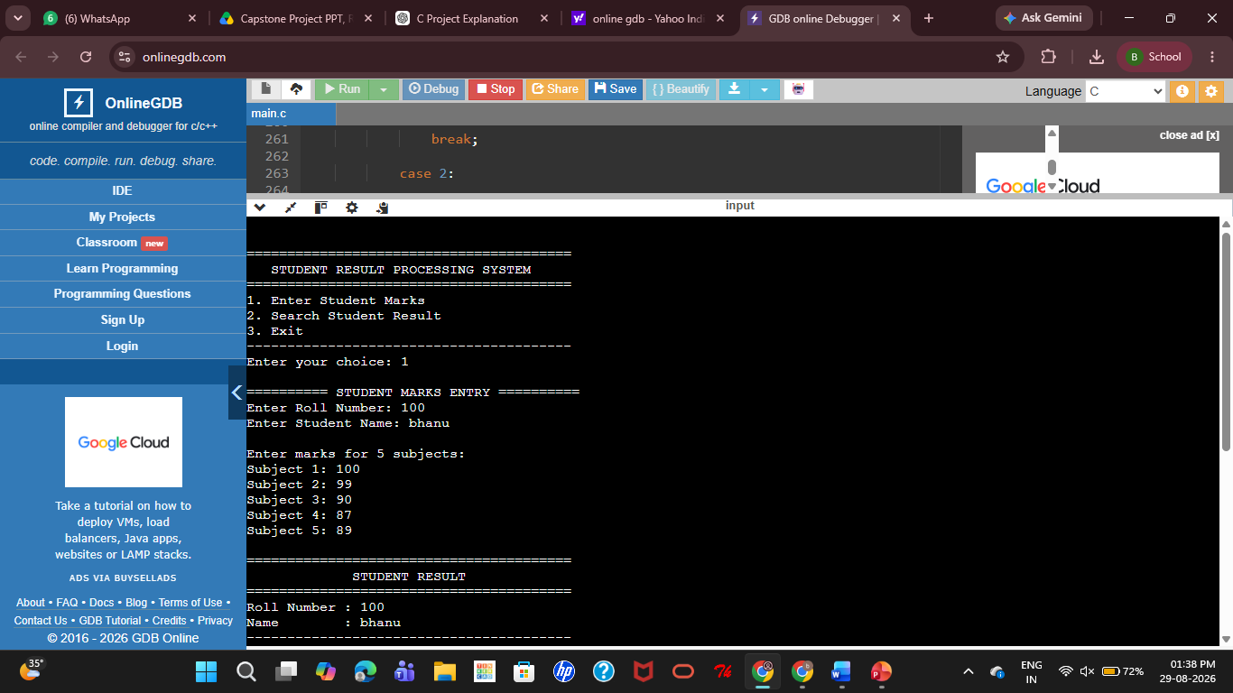

Fig 1: Simulated output 1

CHAPTER – 5
IMPLEMENTATION

5.1 Implementation of Modules
The implementation of the system is divided into several functional modules to simplify development and maintenance.
Student Registration Module
This module collects student information such as Roll Number, Name, Department, and Semester. The entered details are validated and stored permanently in a file.
Marks Entry Module
The administrator enters subject-wise marks for each student. The system checks that the marks are within the valid range and stores them along with the student's record.
Result Processing Module
The application automatically calculates:
- Total Marks
- Average Marks
- Percentage
- Pass/Fail Status
The calculated percentage is then used to generate the appropriate grade according to the predefined grading policy.
Grade Generation Module
Based on the percentage obtained, the system assigns grades automatically.
Percentage | Grade
90–100 | O
80–89 | A+
70–79 | A
60–69 | B+
50–59 | B
40–49 | C
Below 40 | F
File Management Module
This module performs all file operations, including:
- Creating student records
- Reading records
- Updating records
- Searching records
- Deleting records
These operations ensure that student information is permanently stored and easily accessible.
Report Generation Module
After processing, the system generates a detailed report containing:
- Student Details
- Subject-wise Marks
- Total Marks
- Percentage
- Grade
- Result Status

5.2 Program Execution and Sample Output
The execution of the application follows a menu-driven approach. The user selects an operation, enters the required information, and the system performs the requested task.
Program Flow
Start
↓
Display Main Menu
↓
Select Operation
↓
Enter Student Details
↓
Enter Subject Marks
↓
Calculate Total
↓
Calculate Percentage
↓
Generate Grade
↓
Display Result
↓
Store Record in File
↓
Search / Update / Delete (Optional)
↓
Exit
Sample Input
Roll Number : 101
Student Name: Rahul Kumar
Department : BCA
Semester : V

English : 90
Mathematics : 85
Science : 88
Computer : 95
Statistics : 82
Sample Output
------------------------------------------
STUDENT RESULT REPORT
------------------------------------------
Roll Number : 101
Name : Rahul Kumar
Department : BCA
Semester : V

English : 90
Mathematics : 85
Science : 88
Computer : 95
Statistics : 82

------------------------------------------
Total Marks : 440
Percentage : 88.00%
Grade : A+
Result : PASS
------------------------------------------
The implemented system successfully stores the generated result in a file, allowing users to retrieve, update, or delete records whenever required. The modular implementation ensures better performance, maintainability, and ease of future enhancement.

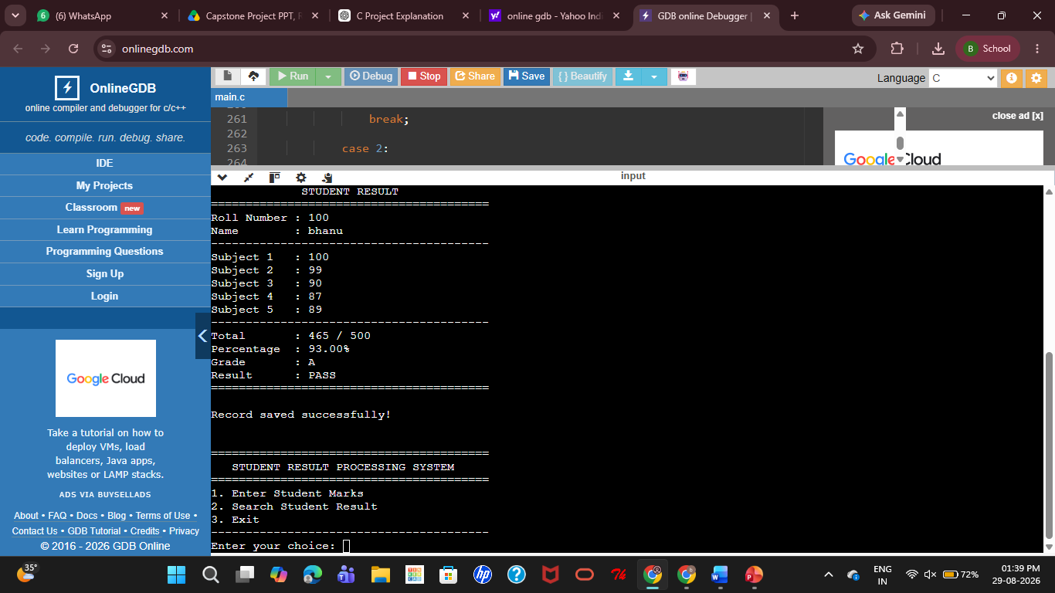

Fig 2: Simulated output 2

CHAPTER – 6 CONCLUSION

The Student Result Processing System and Grade Generation Using File-Based Record Processing has been successfully designed and developed to provide an efficient, accurate, and user-friendly solution for managing student academic records and examination results. The project addresses the major challenges associated with traditional manual result processing systems, such as calculation errors, excessive paperwork, delayed result preparation, and difficulty in maintaining student records. By automating the entire result processing workflow, the system significantly improves the efficiency and reliability of academic record management.

One of the primary objectives of this project was to eliminate the dependency on manual calculations and provide an automated mechanism for calculating total marks, percentages, grades, and pass/fail status. The developed system successfully achieves this objective by using predefined grading rules and automated calculations. Once the marks are entered into the system, it immediately processes the information, calculates the required values, generates the appropriate grade, and stores the complete student record in a file. This automation minimizes human intervention, reduces calculation errors, and ensures fairness and consistency in the evaluation process.

The project makes extensive use of file-based record processing, which serves as an effective alternative to database management systems for small and medium-sized educational institutions. File handling enables permanent storage of student information without requiring expensive database software or dedicated database administrators. The system supports essential file operations such as creating, reading, updating, searching, and deleting student records. These features allow administrators to maintain academic information efficiently while ensuring that records remain available for future reference. The use of file handling also makes the application lightweight, economical, and easy to deploy in environments where database infrastructure is unavailable.

The modular structure of the application contributes significantly to its flexibility and maintainability. Separate modules have been developed for student registration, marks entry, result calculation, grade generation, file management, and report generation. This modular design simplifies program development, testing, debugging, and future enhancements.

References

- Balagurusamy, E. (2023). Programming in ANSI C (8th Edition). McGraw-Hill Education.
- Kernighan, B. W., & Ritchie, D. M. (1988). The C Programming Language (2nd Edition). Prentice Hall.
- Kanetkar, Y. (2024). Let Us C (17th Edition). BPB Publications.
- Schildt, H. (2025). C: The Complete Reference (4th Edition). McGraw-Hill Education.
- Pressman, R. S., & Maxim, B. R. (2026). Software Engineering: A Practitioner's Approach (9th Edition). McGraw-Hill Education.
- Sommerville, I. (2016). Software Engineering (10th Edition). Pearson Education.
- Silberschatz, A., Korth, H. F., & Sudarshan, S. (2025). Database System Concepts (7th Edition). McGraw-Hill Education.
- Date, C. J. (2025). An Introduction to Database Systems (8th Edition). Pearson Education.
- Deitel, P., & Deitel, H. (2034). C How to Program (9th Edition). Pearson Education.
- Rajaraman, V. (2026). Fundamentals of Computers (6th Edition). PHI Learning.

